Question 13.1
Refer to the exhibit.
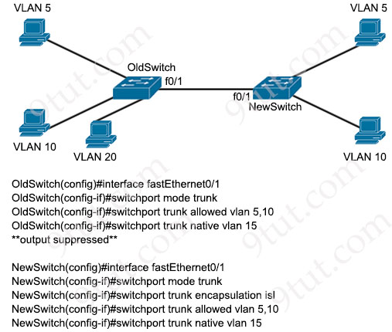
A new VLAN and switch are added to the network. A remote engineer configures OldSwitch and must ensure that the configuration meets these requirements:
* accommodates current configured VLANs
* expands the range to include VLAN 20
* allows for IEEE standard support for virtual LANs
Which configuration on the NewSwitch side of the link meets these requirements?
A.
no switchport trunk encapsulation isl
switchport trunk encapsulation dot1q
switchport trunk allowed vlan add 20
B.
switchport nonnegotiate
no switchport trunk allowed vlan 5,10
switchport trunk allowed vlan 5,10,15,20
C.
no switchport mode trunk
switchport trunk encapsulation isl
switchport mode access vlan 20
D.
switchport mode dynamic
channel-group 1 mode active
switchport trunk allowed vlan 5,10,15,20

Answer: A
Question 13.2
Drag and drop the characteristic from the left onto the IPv6 address type on the right.
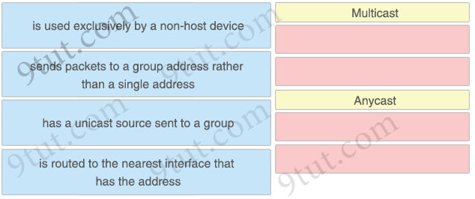

Answer:
Multicast
+ sends packets to a group address rather than a single address
+ has a unicast source sent to a group
Anycast
+ is used exclusively by a non-host device
+ is routed to the nearest interface that has the address
Explanation
An anycast address is an address that is assigned to a set of interfaces that typically belong to different nodes. A packet sent to an anycast address is delivered to the closest interface (as defined by the routing protocols in use) identified by the anycast address.
Anycast addresses can be used only by a device, not a host, and anycast addresses must not be used as the source address of an IPv6 packet.
Reference: https://www.cisco.com/c/en/us/td/docs/ios-xml/ios/ipv6_basic/configuration/xe-3se/5700/ip6-anycast-add-xe.html
Question 13.3
Drag and drop the characteristic from the left onto the IPv6 address type on the right.
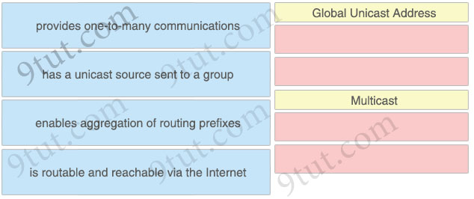

Answer:
Global Unicast Address
+ enables aggregation of routing prefixes
+ is routable and reachable via the Internet
Multicast
+ provides one-to-many communications
+ has a unicast source sent to a group
Question 13.4
How does frame switching function on a switch?
A. forwards frames to a neighbor port using CDP
B. modifies frames that contain a known source VLAN
C. inspects and drops frames from unknown destinations
D. forwards known destinations to the destination port

Answer: D
Question 13.5
What is used as a solution for protecting an individual network endpoint from attack?
A. Router
B. Wireless controller
C. Antivirus software
D. Cisco DNA Center

Answer: C
Question 13.6
Refer to Exhibit.
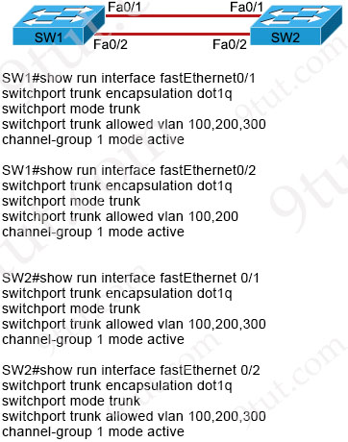
An engineer is building a new Layer 2 LACP EtherChannel between SW1 and SW2. and they executed the given show commands to verify the work. Which additional task must be performed so that the switches successfully bundle the second member in the LACP port-channel?
A. Configure the switchport trunk allowed vlan 300 command on SW1 port-channel 1
B. Configure the switchport trunk allowed vlan 300 command on interface Fa0/2 on SW1
C. Configure the switchport trunk allowed vlan add 300 command on interface Fa0/2 on SW2
D. Configure the switchport trunk allowed vlan add 300 command on SW1 port-channel 1

Answer: D
Explanation
All of the member interfaces of an Etherchannel port must have the same configuration or the Etherchannel interface would not be formed. Therefore we must add VLAN 300 to the interface Fa0/2 on SW1 to match the configuration on interface Fa0/1 by the command “switchport trunk allowed vlan add 300″ on interface Fa0/2 of SW1. But this command does not exist in the four choices so the best alternative command should be answer D. After using this command, two physical interfaces will have the same configuration.
Question 13.7
Which two HTTP methods are suitable for actions performed by REST-based APIs? (Choose two)
A. REMOVE
B. REDIRECT
C. POST
D. GET
E. POP
Answer: C D
Explanation
GET: retrieve data
POST: create data
PUT: fully update (i.e. replace) an existing record
PATCH: update part of an existing record
DELETE: delete records
Question 13.8
What provides connection redundancy increased bandwidth and load sharing between a wireless LAN controller and a Layer 2 switch?
A. VLAN trunking
B. tunneling
C. first hop redundancy
D. link aggregation

Answer: D
Explanation
Cisco Wireless LAN Controller Configuration Guide, Release 7.4
…
When using Link aggregation (LAG) make sure all ports of the controller have the same Layer 2 configuration on the switch side.
Reference: https://www.cisco.com/c/en/us/td/docs/wireless/controller/7-4/configuration/guides/consolidated/b_cg74_CONSOLIDATED/b_cg74_CONSOLIDATED_chapter_010100001.html
Question 13.9
Drag and drop the characteristic from the left onto the IPv6 address type on the right.
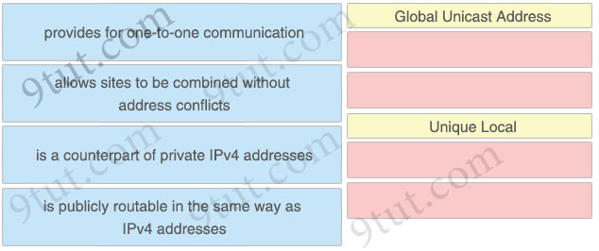

Answer:
Global Unicast Address
+ provides for one-to-one communication
+ is publicly routable in the same way as IPv4 addresses
Unique Local
+ allows sites to be combined without address conflicts
+ is a counterpart of private IPv4 addresses
Explanation
A IPv6 Unique Local Address is an IPv6 address in the block FC00::/7. It is the approximate IPv6 counterpart of the IPv4 private address. It is not routable on the global Internet.
Question 13.10
When the LAG configuration is updated on a Cisco WLC, which additional task must be performed when changes are complete?
A. Flush all MAC addresses from the WLC
B. Re-associate the WLC with the access point.
C. Re-enable the WLC interfaces
D. Reboot the WLC

Answer: D
Explanation
When you enable LAG or make any changes to the LAG configuration, you must immediately reboot the controller.
Reference: https://www.cisco.com/c/en/us/td/docs/wireless/controller/7-4/configuration/guides/consolidated/b_cg74_CONSOLIDATED/b_cg74_CONSOLIDATED_chapter_010100001.html
Question 13.11
Which Cisco proprietary protocol ensures traffic recovers immediately, transparently, and automatically when edge devices or access circuits fail?
A. SLB
B. FHRP
C. VRRP
D. HSRP

Answer: D
Question 13.12
Drag and drop the characteristic from the left onto the IPv6 address type on the right.
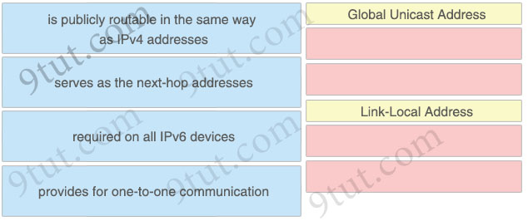

Answer:
Global Unicast Address
+ is publicly routable in the same way as IPv4 addresses
+ provides for one-to-one communication
Link-Local Address
+ serves as the next-hop addresses
+ required on all IPv6 devices
Explanation
To be an IPv6-enabled device, a device must have an IPv6 link-local address. The device doesn’t have to have an IPv6 global unicast address, but it must have a link-local address.
Reference: https://www.ciscopress.com/articles/article.asp?p=2803866&seqNum=4
Question 13.13
What is an enhancement implemented in WPA3?
A. employs PKI and RADIUS to identify access points
B. applies 802.1x authentication and AES-128 encryption
C. uses TKIP and per-packet keying
D. defends against deauthentication and disassociation attacks

Answer: D
Explanation
WPA3 security overcomes this limitation and does not allows TKIP and WEP. Additionally, WPA3 personal and enterprise connections requires PMF (Protected Management Frame) negotiation mandatorily. PMF provides an additional layer of protection from de-authentication and disassociation attacks.
Reference: https://blogs.cisco.com/networking/wpa3-bringing-robust-security-for-wi-fi-networks
Question 13.14
What is a link-local all-nodes IPv6 multicast address?
A. ff02:0:0:0:0:0:0:1
B. 2004:31c:73d9:683e:255::
C. fffe:034:0dd:45d6:789e::
D. fe80:4433:034:0dd::2
Answer: A
Explanation
FF02::1 – the link-local scope address to reach all nodes.
Question 13.15
Refer to the exhibit.
GigabitEthernet1 it up, line protocol is up
Hardware it CSR vNIC, address it 5000.0004.0000 (bia 5000.0004.0000)
Internet address is 192.168.1.1/24
MTU 1500 bytes, BW 1000000 Kbit/sec, DLY 10 usec,
reliability 255/255, txload 1/255, rxload 1/255
Encapsulation ARPA, loopback not set
Keepalive set (10 sec)
Full Duplex, 1000MBps, link type is auto, media type it RJ45
Which format matches the Modified EUI-64 IPv6 interface address for the network 2001:db8::/64?
A. 2001:db8::5000:0004:5678:0090/64
B. 2001:db8:4425:5400:77ff:fe07:/64
C. 2001:db8::5000:00ff:fe04:0000/64
D. 2001:db8::5200:00ff:fe04:0000/64

Answer: D
Explanation
Converting 48-Bit MAC Addresses to IPv6 Modified EUI-64 Identifiers
Of course, most devices still use the older 48-bit MAC address format. These can be converted to EUI-64 and then to modified EUI-64 form for creating an IPv6 interface ID. The process is as follows:
1. We take the 24-bit OUI portion, the left-most 24 bits of the Ethernet address, and put them into the left-most 24 bits of the interface ID. We take the 24-bit local portion (the right-most 24 bits of the Ethernet address) and put it into the right-most 24 bits of the interface ID.
2. In the remaining 16 bits in the middle of the interface ID we put the value “11111111 11111110” (“FFFE” in hexadecimal).
3. The address is now in EUI-64 form. We change the “universal/local” bit (bit 7 from the left) from a zero to a one. This gives us the modified EUI-64 interface ID.
Reference: http://www.tcpipguide.com/free/t_IPv6InterfaceIdentifiersandPhysicalAddressMapping-2.htm
Note: By flipping the 7th bit from the left from 0 to 1, we will have “52” instead of “50” (50 = 01010000)
Question 13.16
What are two disadvantages of a full-mesh topology? (Choose two)
A. It needs a high MTU between sites.
B. It has a high implementation cost.
C. It must have point-to-point communication.
D. It requires complex configuration.
E. It works only with BGP between sites.

Answer: B D
Explanation
We don’t need to set high MTU between sites -> Answer A is not correct.
We can use any connection types (broadcast, point-to-point…) between two devices -> Answer C is not correct.
We can use full-mesh topology with all routing protocols, not only BGP -> Answer E is not correct.
Question 13.17
Drag and drop the characteristic from the left onto the IPv6 address type on the right.
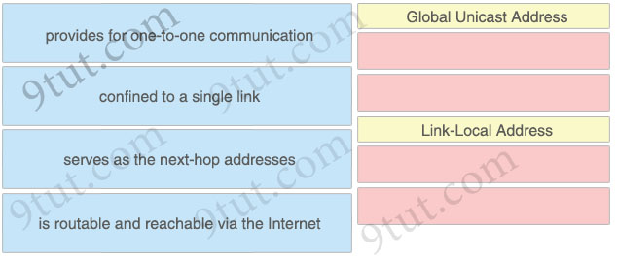

Answer:
Global Unicast Address
+ provides for one-to-one communication
+ is routable and reachable via the Internet
Link-Local Address
+ confined to a single link
+ serves as the next-hop addresses
Question 13.18
How does MAC learning function on a switch?
A. broadcasts frames to all ports without queueing
B. adds unknown source MAC addresses to the address table
C. sends a retransmission request when a new frame is received
D. sends frames with unknown destinations to a multicast group

Answer: B
Explanation
If the source MAC address does not exist, the switch adds the source MAC address to the MAC address table along with the incoming port number.
Question 13.19
What is the purpose of classifying network traffic in QoS?
A. services traffic according to its class
B. identifies the type of traffic that will receive a particular treatment
C. writes the class identifier of a packet to a dedicated field in the packet header
D. configures traffic-matching rules on network devices

Answer: B
Explanation
The goal of network traffic classification is to group traffic based on user-defined criteria so that the resulting
groups of network traffic can then be subjected to specific QoS treatments.
Reference: https://www.cisco.com/c/en/us/td/docs/ios-xml/ios/qos_classn/configuration/15-mt/qos-classn-15-mt-book/qos-classn-ntwk-trfc.pdf
Question 13.20
What is a benefit of using private IPv4 addressing?
A. Multiple companies can use the same addresses without conflicts.
B. Direct connectivity is provided to internal hosts from outside an enterprise network.
C. Communication to the internet is reachable without the use of NAT.
D. All external hosts are provided with secure communication to the Internet.

Answer: A
Question 13.21
What is the advantage of separating the control plane from the data plane within an SDN network?
A. decreases overall network complexity
B. limits data queries to the control plane
C. reduces cost
D. offloads the creation of virtual machines to the data plane

Answer: A
Explanation
Software Defined Networking (SDN) has redefined the way data center networks are deployed and function. The ability to separate the control plane and data plane has lead to simpler design and easy management.
Reference: https://ieeexplore.ieee.org/document/8644332
Question 13.22
Drag and drop the use cases for device-management technologies from the left onto the corresponding.
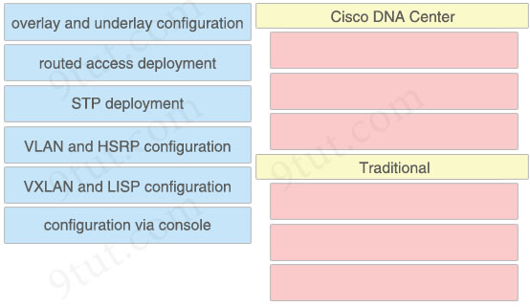

Answer:
Cisco DNA Center
+ overlay and underlay configuration
+ routed access deployment
+ VXLAN and LISP configuration
Traditional
+ STP deployment
+ VLAN and HSRP configuration
+ configuration via console
Question 13.23
Why is a first-hop redundancy protocol implemented?
A. to protect against default gateway failures
B. to prevent loops in a network
C. to enable multiple switches to operate as a single unit
D. to provide load-sharing for a multilink segment

Answer: A
Question 13.24
Which WPA mode uses PSK authentication?
A. Local
B. Client
C. Enterprise
D. Personal

Answer: D
Explanation
Both versions of Wi-Fi Protected Access (WPA/WPA2) can be implemented in either of two modes:
+ Personal or Pre-Shared Key (PSK) Mode: This mode is appropriate for most home networks—but not business networks. You define an encryption passphrase on the wireless router and any other access points (APs). Then the passphrase must be entered by users when connecting to the Wi-Fi network.
Though this mode seems very easy to implement, it actually makes properly securing a business network nearly impossible. Unlike with the Enterprise mode, wireless access can’t be individually or centrally managed. One passphrase applies to all users. If the global passphrase should need to be changed, it must be manually changed on all the APs and computers. This would be a big headache when you need to change it; for instance, when an employee leaves the company or when any computers are stolen or compromised. Unlike with the Enterprise mode, the encryption passphrase is stored on the computers. Therefore, anyone on the computer—whether it be employees or thieves—can connect to the network and also recover the encryption passphrase.
Reference: https://www.ciscopress.com/articles/article.asp?p=1576225
Question 13.25
Drag and drop the AAA features from the left onto the corresponding AAA security services on the right. Not all options are used.
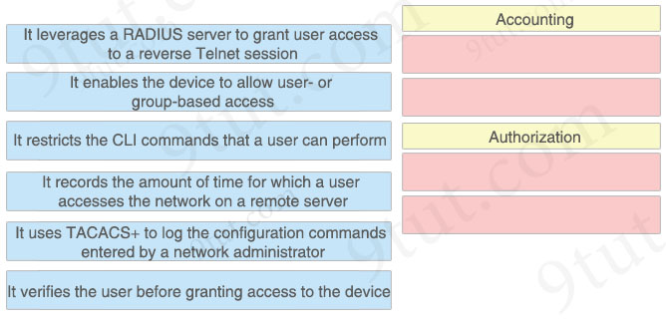

Answer:
Accounting
+ It records the amount of time for which a user accesses the network on a remote server
+ It uses TACACS+ to log the configuration commands entered by a network administrator
Authorization
+ It enables the device to allow user- or group-based access
+ It restricts the CLI commands that a user is able to perform
Explanation
To use RADIUS server to allow a reverse Telnet session we have to use such command “aaa authentication login reverse-access group radius”. Therefore the option “It leverages a RADIUS server to grant user access to a reverse Telnet session” should belong to Authentication, not Authorization.
Note: Reverse telnet allows you to telnet to a device then from that device connect to the console of another device.
Question 13.26
What is a function of the core and distribution layers in a collapsed-core architecture?
A. The router must use IPv4 and IPv6 addresses at Layer 3.
B. The core and distribution layers are deployed on two different devices to enable failover.
C. The router can support HSRP for Layer 2 redundancy in an IPv6 network.
D. The router operates on a single device or a redundant pair.

Answer: D
Explanation
A “collapsed core” is when the distribution layer and core layer functions are implemented by a single device.
Reference: https://www.ciscopress.com/articles/article.asp?p=2202410&seqNum=4
But in reality, we often use redundant pair to increase reliability.
Question 13.27
Drag and drop the IPv6 addresses from the left onto the corresponding address types on the right.
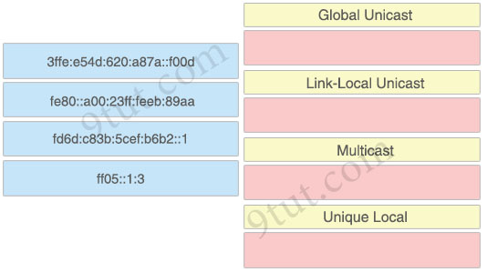

Answer:
Global unicast: 3ffe:e54d:620:a87a::f00d
Link-Local unicast: fe80::a00:23ff:feeb:89aa
Multicast: ff05::1:3
Unique Local: fd6d:c83b:5cef:b6b2::1
Question 13.28
Refer to the exhibit.
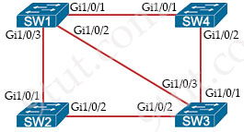
Which switch becomes the root bridge?
A. SW 1
Bridge Priority – 32768
mac-address 0f:d7:9e:13:ab:82
B. SW 4
Bridge Priority – 40960
mac-address 05:d8:33:09:8f:89
C. SW3
Bridge Priority – 32768
mac-address 01:1c:6c:66:b7:70
D. SW2
Bridge Priority – 40960
mac-address 04:44:97:51:63:17

Answer: C
Explanation
The switch with lowest bridge priority will be chosen the root bridge. If many switches have the same bridge priority then the lowest MAC address would be chosen.
Question 13.29
Refer to the exhibit.
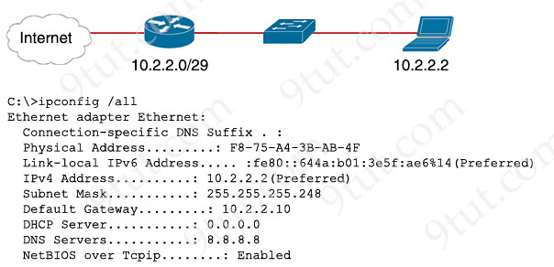
A newly configured PC fails to connect to the internet using TCP port 80 to www.cisco.com. Which setting must be modified for the connection to work?
A. Subnet Mask
B. DNS Servers
C. Default Gateway
D. DHCP Server

Answer: C
Explanation
We see the Subnet Mask of the PC is 255.255.255.248 so it belongs to 10.2.2.0/29 (ranges from 10.2.2.0 to 10.2.2.7). But its default gateway is 10.2.2.10 and it is outside of the PC subnet. This question says only newly configured PC fails to connect to internet so maybe its default gateway was configured wrongly. The IP address of the Default Gateway configured on this new PC must be in 10.2.2.0/29 subnet.
Question 13.30
Refer to the exhibit.
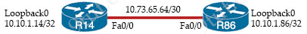
All interfaces are configured with duplex auto and ip ospf network broadcast. Which configuration allows routers R14 and R86 to form an OSPFv2 adjacency and act as a central point for exchanging OSPF information between routers?
Option A  R14#  interface FastEthernet0/0  ip address 10.73.65.65 255.255.255.252  ip ospf priority 0  ip mtu 1500  router ospf 10  router-id 10.10.1.14  network 10.10.1.14 0.0.0.0 area 0  network 10.73.65.64 0.0.0.3 area 0  R86#  interface FastEthernet0/0  ip address 10.73.65.66 255.255.255.252  ip mtu 1500  router ospf 10  router-id 10.10.1.86  network 10.10.1.86 0.0.0.0 area 0  network 10.73.65.64 0.0.0.3 area 0 | Option B  R14#  interface Loopback0  ip ospf 10 area 0  interface FastEthernet0/0  ip address 10.73.65.65 255.255.255.252  ip ospf priority 255  ip ospf 10 area 0  ip mtu 1500  router ospf 10  router-id 10.10.1.14  R86#  interface Loopback0  ip ospf 10 area 0  interface FastEthernet0/0  ip address 10.73.65.66 255.255.255.252  ip ospf 10 area 0  ip mtu 1500  router ospf 10  router-id 10.10.1.86
Option C  R14#  interface FastEthernet0/0  ip address 10.73.65.65 255.255.255.252  ip ospf priority 255  ip mtu 1500  router ospf 10  router-id 10.10.1.14  network 10.10.1.14 0.0.0.0 area 0  network 10.73.65.64 0.0.0.3 area 0  R86#  interface FastEthernet0/0  ip address 10.73.65.66 255.255.255.252  ip mtu 1400  router ospf 10  router-id 10.10.1.86  network 10.10.1.86 0.0.0.0 area 0  network 10.73.65.64 0.0.0.3 area 0 | Option D  R14#  interface Loopback0  ip ospf 10 area 0  interface FastEthernet0/0  ip address 10.73.65.65 255.255.255.252  ip ospf 10 area 0  ip mtu 1500  router ospf 10  router-id 10.10.1.14  network 10.10.1.14 0.0.0.0 area 0  network 10.73.65.64 0.0.0.3 area 0  R86#  interface FastEthernet0/0  ip address 10.73.65.66 255.255.255.252  ip mtu 1400  router ospf 10  router-id 10.10.1.86  network 10.10.1.86 0.0.0.0 area 0  network 10.73.65.64 0.0.0.3 area 0
A. Option A
B. Option B
C. Option C
D. Option D

Answer: B
Explanation
In Option C and Option D, the MTUs of two Fa0/0 interfaces are mismatched so they cannot form OSPF adjacency -> Option C and Option D are not correct.
In Option B, R14 Fa0/0 interface is configured with OSPF priority 255 so surely it would become DR -> This is the best answer.
Question 13.31
Drag and drop the characteristic from the left onto the cable type on the right.
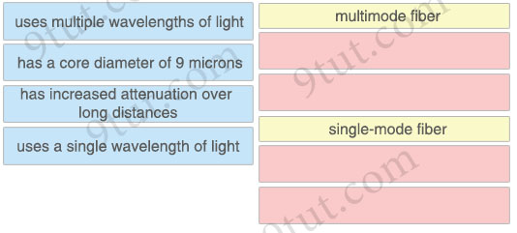

Answer:
multimode fiber:
+ uses multiple wavelengths of light
+ has increased attenuation over long distances
single-mode fiber:
+ has a core diameter of 9 microns
+ uses a single wavelength of light
Explanation
Single-mode fiber allows only one mode of light to propagate. Because of this, the number of light reflections created as the light passes through the core decreases, lowering attenuation and creating the ability for the signal to travel further. This application is typically used in long distance, higher bandwidth.
Because of the high dispersion and attenuation rate with multimode fiber cable, the quality of the signal is reduced over long distances.
Reference: https://www.multicominc.com/training/technical-resources/single-mode-vs-multi-mode-fiber-optic-cable/
Question 13.32
An engineer must configure a core router with a floating static default route to the backup router at 10.200.0.2. Which command meets the requirements?
A. ip route 0.0.0.0 0.0.0.0 10.200.0.2 floating
B. ip route 0.0.0.0 0.0.0.0 10.200.0.2
C. ip route 0.0.0.0 0.0.0.0 10.200.0.2 10
D. ip route 0.0.0.0 0.0.0.0 10.200.0.2 1

Answer: C
Question 13.33
Which interface is used to send traffic to the destination network?
D 10.87.161.30/27 [90/10331] via G0/17
D 10.87.161.30/27 [90/44594] via G0/8
O 10.87.161.30/27 [110/7820] via G0/24
O 10.87 161.30/27 [110/7879] via G0/1
A. G0/1
B. G0/8
C. G0/24
D. G0/17

Answer: D
Explanation
The first entry has lowest AD so it will be installed into the routing table and it has the lowest metric so it is the best route.
Question 13.34
Refer to the exhibit.
R1# show ip route
Codes: C - connected, S — static, I — IGRP, R — RIP, M — mobile, B - BGP
D - EIGRP, EX - EIGRP external, O - OSPF, XA - OSPF inter area
N1 - OSPF NSSA external type 1, N2 - OSPF NSSA external type 2
E1 - OSPF external type 1, E2 - OSPF external type 2, E — EGP
i - IS-IS, LI - IS-IS level-1, L2 — IS-IS level-2, * — candidate default
U - per-user static route, o - ODR
Gateway of last resort is not set
C 172.16.0.0/16 is directly connected, Loopback0
172.16.0.0/16 is variably subnetted, 4 subnets, 2 masks
O 172.16.1.3/32 [110/100] via 10.0.1.100, 00:39:08, Serial0
O 172.16.1.9/32 [110/5] via 172.16.1.50, 00:43:01, Gigabit Ethernet 0/0
D 172.16.1.4/30 [90/7445] via 172.16.9.5, 00:39:08, Gigabit Ethernet 0/0
[90/7445] via 172.16.4.4, 00:39:08, Gigabit Ethernet 0/4
How does router R1 handle traffic to the 172.16.1.4/30 subnet?
A. It sends all traffic over the path via 172.16.4.4
B. It sends all traffic over the path via 10.0.1 100
C. It sends all traffic over the path via 172.16.9.5 using 172.16.4.4 as a backup
D. It load-balances traffic over 172.16.9.5 and 172.16.4.4

Answer: D
Question 13.35
Drag and drop the characteristic from the left onto the IPv6 address type on the right.
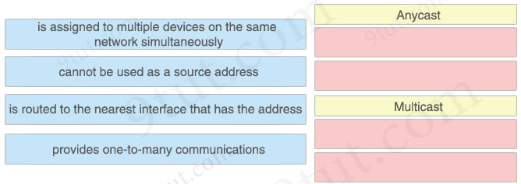

Answer:
Anycast
+ is assigned to multiple devices on the same network simultaneously
+ is routed to the nearest interface that has the address
Multicast
+ cannot be used as a source address
+ provides one-to-many communications
Explanation
An anycast address is an address that is assigned to a set of interfaces that typically belong to different nodes. A packet sent to an anycast address is delivered to the closest interface (as defined by the routing protocols in use) identified by the anycast address.
For the option “cannot be used as a source address”, it is correct for both Anycast and Multicast so we have to assign it to Multicast as other options are only suitable for Anycast.
Reference: https://www.cisco.com/c/en/us/td/docs/ios-xml/ios/ipv6_basic/configuration/xe-3se/5700/ip6-anycast-add-xe.html
Question 13.36
What is a characteristic of an SSID in wireless networks?
A. uses policies to prevent unauthorized users
B. identifies an access point on a WLAN
C. prompts a user for a login ID
D. associates a name to a WLAN

Answer: D
Question 13.37
What is represented by the word “port” within this JSON schema?
1 [
2 {"IDS": "IPS_pittsburgh", "port":"te8/30"},
3 {"router": "R20", "port":"ge9/23"},
4 {"firewall": "FW42", "port":"fe3/24"},
5 ]
A. value
B. array
C. key
D. object

Answer: C
Question 13.38
Drag and drop the IPv6 address from the left onto the type on the right.
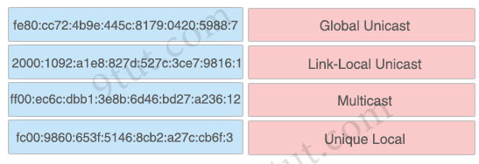

Answer:
+ Global Unicast: 2000:1092 :a1e8:827d:527c:3ce7:9816:1
+ Link-Local Unicast: fe80:cc72:4b9e:445c:8179:0420:5988:7
+ Multicast: ff00:ec6c:dbb1:3e8b:6d46:bd27:a236:12
+ Unique Local: fc00:9860:653f:5146:8cb2:a27c:cb6f:3
Question 13.39
Drag and drop the characteristic from the left onto the cable type on the right.
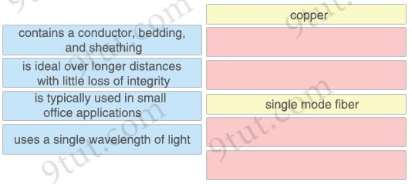

Answer:
copper:
+ contains a conductor, bedding, and sheathing
+ is typically used in small office applications
single mode fiber:
+ is ideal over longer distances with little loss of integrity
+ uses a single wavelength of light
Question 13.40
What is represented by the word “ge3/36” within this JSON schema?
1 [
2 {"VPN concentrator": "VPN36", "interface":"ge3/36"},
3 {"load balancer": "LB33", "interface":"te7/10"},
4 {"switch": "SW31", "interface":"fe2/25"},
5 ]
A. value
B. array
C. key
D. object

Answer: A
Explanation
JSON syntax structure:
+ A key/value pair consists of a key (must be a string in double quotation marks ""), followed by a colon :, followed by a value. For example: “name”:”John”
Therefore in this question, “interface” is the key while “ge3/36” is the value.
Question 13.41
Drag and drop the characteristic from the left onto the IPv6 address type on the right.
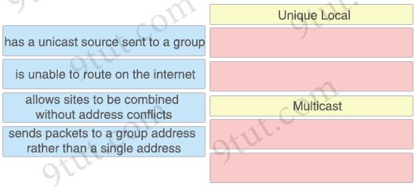

Answer:
Unique Local
+ is unable to route on the internet
+ allows sites to be combined without address conflicts
Multicast
+ has a unicast source sent to a group
+ sends packets to a group address rather than a single address
Question 13.42
What is a characteristic of encryption in wireless networks?
A. uses policies to prevent unauthorized users
B. prevents the interception of data as it transits a network
C. provides increased protection against spyware
D. converts electrical current to radio waves

Answer: B
Explanation
Data encryption protects the vulnerable wireless link between client devices and access points by encrypting all data in the transmission.
Reference: https://www.cityu.edu.hk/csc/netcomp/dec2009-2.htm
Question 13.43
What is a characteristic of private IPv4 addressing?
A. complies with PCI regulations
B. is used on internal hosts that stream data solely to external resources
C. provides an added level of protection against internet threats
D. enables secure connectivity over the internet

Answer: C
Explanation
By using private IPv4 addressing, an Internet threats cannot reach the internal hosts directly, thus it provides an additional level of protection against Internet threats.
Question 13.44
Which interface is used to send traffic to the destination network?
D 10.214.247.237/28 [90/2170] via G0/12
D 10.214.247.237/28 [90/46985] via G0/19
O 10.214.247.237/28 [110/665] via G0/9
O 10.214.247.237/28 [110/3399] via G0/1
A. G0/12
B. G0/1
C. G0/9
D. G0/19

Answer: A
Explanation
The first entry has lowest AD (90) so it will be installed into the routing table and it has the lowest metric (2170) so it is the best route.
Question 13.45
Which interface is used to send traffic to the destination network?
O 10.139.120.253/29 [110/9443] via G0/20
O 10.139.120.253/29 [110/29560] via G0/16
R 10.139.120.253/29 [120/12] via G0/11
R 10.139120 253/29 [120/6] via G0/9
A. G0/11
B. G0/20
C. G0/9
D. G0/16

Answer: B
Explanation
The first entry has lowest AD (110) and lowest metric (9443) so it is the best route and will be installed into the routing table.
Question 13.46
Drag and drop the characteristic from the left onto the cable type on the right.
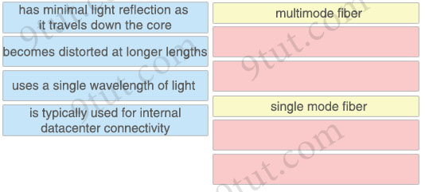
Answer:
multimode fiber:
+ becomes distorted at longer lengths
+ is typically used for internal datacenter connectivity
single mode fiber:
+ has minimal light reflection as it travels down the core
+ uses a single wavelength of light
Question 13.47
What is a characteristic of an SSID in wireless networks?
A. broadcasts a beacon signal to announce its presence by default
B. uses policies to prevent unauthorized users
C. converts electrical current to radio waves
D. prompts a user for a login ID

Answer: A
Question 13.48
Refer to the exhibit.
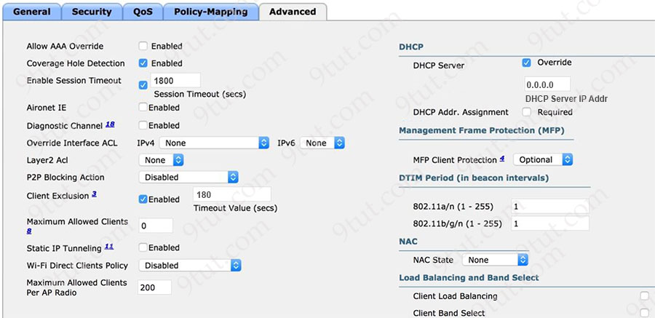
The P2P Blocking Action option is disabled on the WLC. The security team has a new requirement for each client to retain their assigned IP addressing as the clients move between locations in the campus network. Which action completes this configuration?
A. Set the P2P Blocking Action option to Forward-UpStream.
B. Enable the Static IP Tunneling option.
C. Check the DHCP Addr. Assignment check box.
D. Disable the Coverage Hole Detection option.

Answer: B
Explanation
Dynamic Anchoring for Clients with Static IP
At times you may want to configure static IP addresses for wireless clients. When these wireless clients move about in a network, they could try associating with other controllers. If the clients try to associate with a controller that does not support the same subnet as the static IP, the clients fail to connect to the network. You can now enable dynamic tunneling of clients with static IP addresses.
Dynamic anchoring of static IP clients with static IP addresses can be associated with other controllers where the client’s subnet is supported by tunneling the traffic to another controller in the same mobility group. This feature enables you to configure your WLAN so that the network is serviced even though the clients use static IP addresses.
Reference: https://www.cisco.com/c/en/us/td/docs/wireless/controller/7-4/configuration/guides/consolidated/b_cg74_CONSOLIDATED/b_cg74_CONSOLIDATED_chapter_010011000.html
Question 13.49
Drag and drop the characteristics of transport layer protocols from the left onto the corresponding protocols on the right.
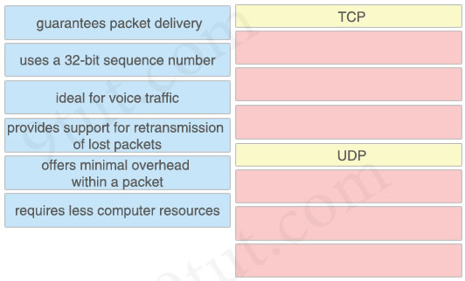

Answer:
TCP
+ guarantees packet delivery
+ uses a 32-bit sequence number
+ provides support for retransmission of lost packets
UDP
+ ideal for voice traffic
+ offers minimal overhead within a packet
+ requires less computer resources
Question 13.50
What is a reason why a company would choose to use network automation in an enterprise?
A. Provide data services faster.
B. Enable network segmentation.
C. Mitigate spanning-tree loop avoidance.
D. Implement granular QoS.

Answer: A
Question 13.51
Refer to the exhibit.
router# show ip route
...
D 172.16.32.0/26 [90/25789217] via 10.0.0.1
R 172.16.32.0/24 [120/4] via 10.0.0.2
O 172.16.32.0/19 [110/229840] via 10.0.0.3
C 172.16.32.32/32 is directly connected, Loopback0
C 172.16.32.4/30 is directly connected, GigabitEthernet0/0
A packet sourced from 172.16.32.254 is destined for 172.16.32.8. What is the subnet mask of the preferred destination route?
A. 255.255.224.0
B. 255.255.255.0
C. 255.255.255.192
D. 255.255.255.252

Answer: C
Explanation
The destination of 172.16.32.8 does not belong to 172.16.32.4/30 (which ranges from 172.16.32.4 to 172.16.32.7) or 172.16.32.32 so the best subnet is 172.16.32.0/26.
Question 13.52
Which WLC interface provides out-of-band management in the Cisco Unified Wireless Network Architecture?
A. dynamic
B. AP-Manager
C. virtual
D. service port

Answer: D
Explanation
The service-port interface is used for out-of-band management of the controller.
Question 13.53
Refer to the exhibit.
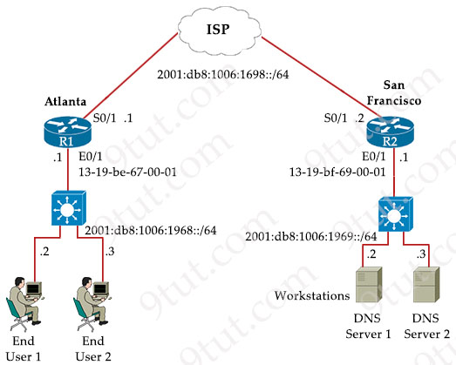
The IPv6 address for the LAN segment on router R1 must be configured using the EUI-64 format. When configured which ipv6 address is produced by the router?
A. 2001:db8:1006:1968:4564:877F:FE99:1
B. 2001:db8:1006:1968:1119:BEFF:FE67:1
C. 2001:db8:1006:1968:1130:ABFF:FECC:1
D. 2001:db8:1006:1968:12D8:BAFE:FF01:1

Answer: B
Explanation
The EUI-64 format must have “FF:FE” in the middle of the MAC address of E0/1 interface of R1 -> Only answer B and answer C are correct.
Only answer B has correct IPv6 of the MAC address of E0/1 interface of R1 (end with “67:1”) -> This is the correct answer.
Question 13.54
Which IPsec encryption mode is appropriate when the destination of a packet differs from the security termination point?
A. tunnel
B. main
C. aggressive
D. transport

Answer: A
Explanation
Encryption Technologies
There are two encryption modes available for IPsec. Both modes have their own uses and should be used with caution depending upon the solution.
Tunnel Mode
This encrypts both the payload and the header. IPsec in tunnel mode is used when the destination of the packet is different than the security termination point. The most common use of this mode is between gateways or from end station to gateway. The gateway serves as a proxy for the hosts. So when the origin of the packets differs from the device that is providing security, tunnel mode is used.
Reference: https://www.rapid7.com/blog/post/2017/02/13/basics-of-ipsec/
Question 13.55
Why is UDP more suitable than TCP for applications that require low latency, such as VoIP?
A. UDP reliably guarantees delivery of all packets, and TCP drops packets under heavy load.
B. TCP uses congestion control for efficient packet delivery, and UDP uses flow control mechanisms for the delivery of packets.
C. UDP uses sequencing data for packets to arrive in order, and TCP offers the capability to receive packets in random order.
D. TCP sends an acknowledgment for every packet that is received, and UDP operates without acknowledgments.

Answer: D
Explanation
Both flow control and congestion control are traffic controlling methods in TCP. And only TCP uses sequencing data for packets to arrive in order.
Question 13.56
Refer to the exhibit.
Router# show interface FastEthernet0/0
FastEthernet0/0 is up, line protocol is up
Hardware is Gt96k FE, address is 0017.59b2.7fb2 (bia 0017.59b2.7fb2) Internet address is 10.0.0.2/30
MTU 1500 bytes, BW 100000 Kbit/sec, DLY 100 usec,
reliability 255/255, txload 1/255, rxload 1/255
Encapsulation ARPA, loopback not set
Keepalive set (10 sec)
Half-duplex, 100Mb/s, 100BaseTX/FX
ARP type: ARPA, ARP Timeout 04:00:00
Last input 00:00:04, output 00:00:04, output hang sever
Last clearing of "show interface” counters never
Input queue: 0/75/0/0 (size/max/drops/flushes); Total output drops: 1 Queueing strategy: fifo
Output queue: 0/40 (size/max)
5 minute input rate 516000 bits/sec, 45 packets/sec
5 minute output rate 516000 bits/sec, 46 packets/sec
13282 packets input, 20075670 bytes
Received 25 broadcasts, 0 runts, 0 giants, 0 throttles
383 input errors, 383 CRC, 0 frame, 0 overrun, 0 ignored
0 watchdog
0 input packets with dribble condition detected
13438 packets output, 20084258 bytes, 0 underruns
0 output errors, 831 collision, 5 interface resets
11 unknown protocol drops
0 babbles, 0 late collision, 0 deferred
0 lost carrier, 0 no carrier
0 output buffer failures, 0 output buffers swapped out
Users at a branch office are experiencing application performance issues, poor VoIP audio quality, and slow downloads. What is the cause of the issues?
A. QoS queuing
B. interface configuration
C. broadcast storm
D. overutilization

Answer: B
Explanation
TXLoad is the amount of traffic being transmitted from your interface and the RXLoad is the amount of traffic received on the interface. Both of them are 1 in this question so answer D is not the problem.
This interface received “25 broadcasts” so answer C is not the problem.
Answer A is not the problem as “Input queue: 0/75/0/0 (size/max/drops/flushes); Total output drops: 1 Queueing strategy: fifo Output queue: 0/40 (size/max)”
Therefore only answer B is left. Also this interface was configured in “half-duplex” and has high “input errors” (383) and high “collision” (831) so the most likely cause of this problem is “interface configuration” and maybe the other end was configured in full-duplex, which creates a duplex mismatched problem.
Question 13.57
Refer to the exhibit.
0ldR#show ip ospf interface
GigabitEthernet0/0/0 is up, line protocol is up
Internet address is 192.168.1.2/24, Area 0
Process ID 1, Router ID 192.168.1.1, Network Type BROADCAST, Cost: 1 Transmit Delay is 1 sec, State DROTHER, Priority 1
Designated Router (ID) 192.168.1.1, Interface address 192.168.1.1
Backup Designated Router (ID) 192.168.1.1, Interface address 192.168.1.1
Timer intervals configured, Hello 10, Dead 40, Wait 40, Retransmit 5
Hello due in 00:00:01
Index 1/1, flood queue length 0
Neighbor Count is 1, Adjacent neighbor count is 2

R2#show ip ospf interface
GigabitEthernet0/0/0 is up, line protocol is up
Internet address is 192.168.1.1/24, Area 0
Process ID 1, Router ID 192.168.1.1, Network Type BROADCAST, Cost: 1
Transmit Delay is 1 sec, State DROTHER, Priority 1
Designated Router (ID) 192.168.1.1, Interface address 192.168.1.2
Backup Designated Router (ID) 192.168.1.1, Interface address 192.168.1.2
Timer intervals configured, Hello 10, Dead 40, Wait 40, Retransmit 5
Hello due in 00:00:02
Index 2/2, flood queue length 0
Neighbor Count is 1, Adjacent neighbor count is 2
Router OldR is replacing another router on the network with the intention of having OldR and R2 exchange routes. After the engineer applied the initial OSPF configuration, the routes were still missing on both devices. Which command sequence must be issued before the clear IP ospf process command is entered to enable the neighbor relationship?
A. OldR(config)#router ospf 1
OldR(config-router)#no router-id 192.168.1.1
B. OldR(config)#interface g0/0/0
OldR(config-if)#ip ospf dead-interval 15
C. OldR(config)#interface g0/0/0
OldR(config-if)#ip ospf hello-interval 15
D. OldR(config)#router ospf 1
OldR(config-router)# network 192.168.1.0 255.255.255.0 area 2

Answer: A
Explanation
Two routers in the exhibit have the same router-id of 192.168.1.1 so they cannot form neighbor relationship. Therefore we need to clear the router-id of one of the router. Hopefully the OldR will choose another router-id (maybe 192.168.1.2) automatically after resetting.
Question 13.58
Refer to the exhibit.
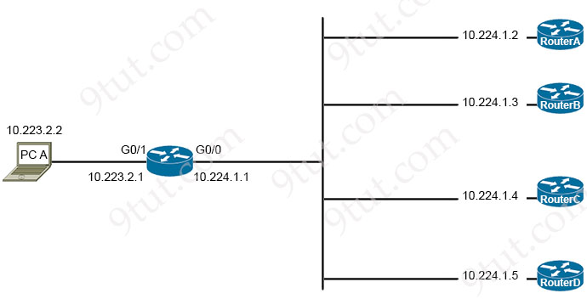
Router-Y#show ip route

Codes: L - local, C - connected, S - static, R - RIP, M - mobile, B - BGP
D - EIGRP, EX - EIGRP external, O - OSPF, IA - OSPF inter area
N1 - OSPF NSSA external type 1, N2 - OSPF NSSA external type 2
E1 - OSPF external type 1, E2 - OSPF external type 2
i - IS-IS, su - IS-IS summary, L1 - IS-IS level-1, L2 - IS-IS level-2
ia - IS-IS inter area, * - candidate default, U - per-user static route
o - ODR, P - periodic downloaded static route, H - NHRP, l - LISP
+ - replicated route, % - next hop override, p - overrides from PfR

Gateway of last resort is not set

10.0.0.0/8 is variably subnetted
B 10.0.0.0/8 [1/0] via 10.224.1.2
B 10.27.150.224/27 [20/0] via 10.224.1.3, 1w6d
S 10.128.0.0/9 [1/0] via 10.224.1.3
B 10.224.0.0/11 [20/0] via 10.224.1.5, 5d18h
B 10.224.0.0/15 [20/0] via 10.224.1.4, 5d18h
C 10.223.0.0/24 is directly connected, GigabitEthernet0/1
C 10.224.0.0/24 is directly connected, GigabitEthernet0/0
B 10.226.34.0/24 [20/0] via 10.224.1.5, 5d18h
PC A is communicating with another device at IP address 10.225.34.225. Through which router does router Y route the traffic?
A. router A
B. router B
C. router C
D. router D

Answer: C
Explanation
The destination IP address 10.225.34.225 belongs to 10.224.0.0/15 subnet (which ranges from 10.224.0.0 to 10.225.255.255) and this is the longest prefix subnet so router Y will send traffic from PC A to 10.224.1.4, which is router C.
Question 13.59
An engineer needs to configure an access point to forward all client traffic through a wireless controller. Which mode must be enabled to accomplish this task?
A. local
B. monitor
C. autonomous
D. rogue detector

Answer: A
Explanation
Local mode (default mode): An AP configured in Local mode tunnels all the client traffic for WLANs is forwarded via the CAPWAP (Control and Provisioning of Wireless Access Points) tunnel to the WLC (Wireless Controller) -> Answer A is correct.
Note:
Autonomous: self-sufficient and standalone. Used for small wireless networks. Each autonomous AP must be configured with a management IP address so that it can be remotely accessed using Telnet, SSH, or a web interface. Each AP must be individually managed and maintained unless you use a management platform such as Cisco DNA Center.
Monitor mode: does not transmit at all. It acts like a dedicated sensor for location-based services (LBS), rogue AP detection, and Checks Intrusion Detection System (IDS). In this mode, AP will not broadcast an SSID so clients are unable to connect to it.
Rogue detector mode: monitor for rogue APs. It does not handle data at all.
Question 13.60
What is the root port in STP?
A. It is the port with the highest priority toward the root bridge.
B. It is the port that is elected only when the root bridge has precisely one port on a single LAN segment.
C. It is the port on a switch with the lowest cost to reach the root bridge.
D. It is the port on the root switch that leads to the designated port on another switch.

Answer: C
Explanation
The root port is always the link connected to the root bridge, or the shortest path to the root bridge.
Reference: https://community.cisco.com/t5/switching/stp-root-port-vs-designated-port/td-p/1517842
Question 13.61
An Ethernet frame arrived at switch interface G0/1, but the destination MAC address is missing from the MAC address table. How does the switch process the frame?
A. It sends an ARP request to attempt to locate the destination.
B. It updates the destination to FFFF.FFFF.FFFF.
C. It drops the frame and notifies the sending host.
D. It floods the frame out of the remaining switch interfaces.

Answer: D
Question 13.62
In which circumstance would a network architect decide to implement a global unicast subnet instead of a unique local unicast subnet?
A. when the subnet must be available only within an organization
B. when the subnet does not need to be routable
C. when the addresses on the subnet must be equivalent to private IPv4 addresses
D. when the subnet must be routable over the internet

Answer: D
Question 13.63
Which Windows command is used instead of the route print command to display the contents of the IP routing table?
A. netstat-n
B. ipconfig
C. ifconfig
D. netstat-r

Answer: D
Explanation
The “route print” and netstat -r” commands are very similar. This is the output of the “route print” command:
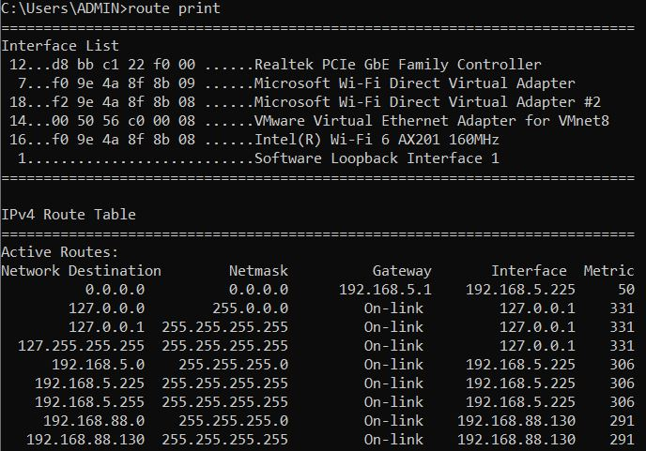
And “netstat -r” command:
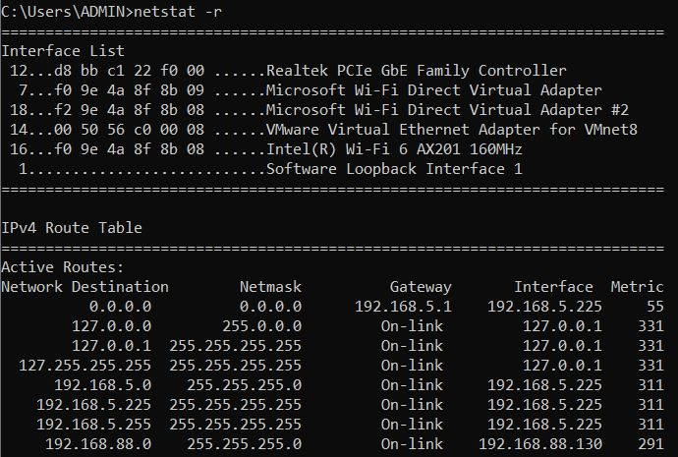
Note: “-r” means “displays the routing table”
Question 13.64
What differentiates the Cisco OfficeExtend AP mode from FlexConnect AP mode?
A. FlexConnect allows a personal SSID to be configured on the AP, and personal SSIDs are not supported with OfficeExtend.
B. OfficeExtend does not support DTLS tunneling of traffic to the WLC, and FlexConnect tunnels traffic to the WLC with DTLS.
C. OfficeExtend tunnels all traffic through the WLC, and FlexConnect terminates client traffic at the AP switch port.
D. FlexConnect must be deployed behind a router that NATs the client traffic, and OfficeExtend uses public IP sources.

Answer: C
Explanation
A controller with OfficeExtend access points in an access point group publishes only up to 15 WLANs to each connected OfficeExtend access point because it reserves one WLAN for the personal SSID -> OfficeExtend support personal SSID -> Answer A is not correct.
A Cisco OfficeExtend access point (Cisco OEAP) provides secure communications from a controller to a Cisco AP at a remote location, seamlessly extending the corporate WLAN over the Internet to an employee’s residence. The user’s experience at the home office is exactly the same as it would be at the corporate office. Datagram Transport Layer Security (DTLS) encryption between the access point and the controller (-> Answer B is not correct) ensures that all communications have the highest level of security.
Cisco OEAPs are designed to work behind a router or other gateway device that is using network address translation (NAT) -> Answer D is not correct.
Reference: https://www.cisco.com/c/en/us/td/docs/wireless/controller/8-5/config-guide/b_cg85/configuring_officeextend_access_points.html
OEAP tunnels back to a Cisco WLC with an IPsec VPN tunnel.
With FlexConnect, AP simply terminates user traffic in a VLAN & destined to gateway defined on a local switch.
Question 13.65
Which type of IPv4 address must be assigned to a server to protect it from external access and allow only internal users access while restricting internet access?
A. global unicast
B. public
C. private
D. multicast

Answer: C
Question 13.66
Which function generally performed by a traditional network device is replaced by a software-defined controller?
A. encryption and decryption for VPN link processing
B. building route tables and updating the forwarding table
C. changing the source or destination address during NAT operations
D. encapsulation and decapsulation of packets in a data-link frame

Answer: B
Question 13.67
Refer to the exhibit.
R1# show ip route | begin gateway
Gateway of last resort is not set
172.16.0.0/16 is variably subnetted, 3 subnets, 2 masks
172.16.1.0/24 is directly connected, FastEthernet0/0
172.16.1.1/32 is directly connected, FastEthernet0/0
172.16.2.0/24 [120/2] via 207.165.200.250, 00:00:25, Serial0/0/0
192.168.1.0/24 [110/84437] via 207.165.200.254, 00:00:17, Serial0/0/1
192.168.2.0/24 [90/3164437] via 207.165.200.254, 00:00:15, Serial0/0/1
207.165.200.0/24 is variably subnetted, 5 subnets, 2 masks
207.165.200.244/30 [1/1] via 207.169.200.254, Serial0/0/1
207.165.200.248/30 is directly connected, Serial0/0/0
207.165.200.249/32 is directly connected, Serial0/0/0
207.165.200.252/30 is directly connected, Serial0/0/1
207.165.200.253/32 is directly connected, Serial0/0/1
Drag and drop the learned prefixes from the left onto the preferred route methods from which they were learned on the right.
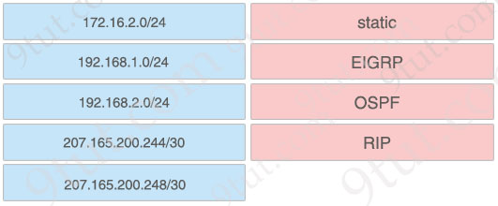

Answer:
+ static: 207.165.200.244/30
+ EIGRP: 192.168.2.0/24
+ OSPF: 192.168.1.0/24
+ RIP: 172.16.2.0/24
Explanation
The output in this question removed the symbols which represent for the routing protocols used so we have to remember the Administrative Distances (AD) of popular routing protocols to figure out which routing protocols were used.
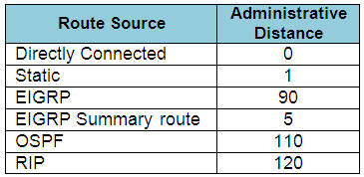
The AD is the first parameter in the square bracket. For example from the line “172.16.2.0/24 [120/2] via …” we learn that the AD of this routing protocol is 120, which is RIP.
Question 13.68
What describes the functionality of southbound APIs?
A. They use HTTP messages to communicate.
B. They enable communication between the controller and the network device.
C. They convey information from the controller to the SDN applications.
D. They communicate with the management plane.

Answer: B
Question 13.69
What are two purposes of HSRP? (Choose two)
A. It groups two or more routers to operate as one virtual router.
B. It improves network availability by providing redundant gateways.
C. It passes configuration information to hosts in a TCP/IP network.
D. It helps hosts on the network to reach remote subnets without a default gateway.
E. It provides a mechanism for diskless clients to autoconfigure their IP parameters during boot.

Answer: A B
Question 13.70
A network engineer must configure an access list on a new Cisco IOS router. The access list must deny HTTP traffic to network 10.125.128.32/27 from the 192.168.240.0/20 network, but it must allow the 192.168.240.0/20 network to reach the rest of the 10.0.0.0/8 network. Which configuration must the engineer apply?
Option A
ip access-list extended deny_outbound
10 deny tcp 10.125.128.32 255.255.255.224 192.168.240.0 255.255.240.0 eq 443
20 deny tcp 192.168.240.0 255.255.240.0 10.125.128.32 255.255.255.224 eq 443
30 permit ip 192.168.240.0 255.255.240.0 10.0.0.0 255.0.0.0
Option B
ip access-list extended deny_outbound
10 permit ip 192.168.240.0 255.255.240.0 10.0.0.0 255.0.0.0
20 deny tcp 192.168.240.0 255.255.240.0 10.125.128.32 255.255.255.224 eq 443
30 permit ip any any
Option C
ip access-list extended deny_outbound
10 deny tcp 192.168.240.0 0.0.15.255 10.125.128.32 0.0.0.31 eq 80
20 permit ip 192.168.240.0 0.0.15.255 10.0.0.0 0.255.255.255
30 deny ip any any log
Option D
ip access-list extended deny_outbound
10 deny tcp 192.168.240.0 0.0.15.255 any eq 80
20 deny tcp 192.168.240.0 0.0.15.255 10.125.128.32 0.0.0.31 eq 80
30 permit ip 192.168.240.0 0.0.15.255 10.0.0.0 0.255.255.255
A. Option A
B. Option B
C. Option C
D. Option D

Answer: C
Explanation
This question only asks to deny HTTP traffic so the port must be “eq 80”, not 443 (for HTTPS) -> Only Option C and Option D are correct. But Option D denies all HTTP traffic from 192.168.24.0/20 with the first statement “10 deny tcp 192.168.240.0 0.0.15.255 any eq 80 ” so it is not correct.
Question 13.71
A DHCP pool has been created with the name NOCC. The pool is using 192.168.20.0/24 and must use the next to last usable IP address as the default gateway for the DHCP clients. What is the next step in the process?
A. default-router 192.168.20.253
B. network 192.168.20.254 255.255.255.0 secondary
C. ip default-gateway 0.0.0.0 0.0.0.0 192.168.20.253
D. next-server 192.168.20.254

Answer: A
Question 13.72
What is the role of SNMP in the network?
A. to monitor network devices and functions using a TCP underlay that operates on the presentation layer
B. to collect data directly from network devices using an SSL underlay that operates on the transport layer
C. to monitor and manage network devices using a UDP underlay that operates on the application layer
D. to collect telemetry and critical information from network devices using an SSH underlay that operates on the network layer

Answer: C
Explanation
SNMP uses UDP as its transport protocol because it has no need for the overhead of TCP. “Reliability” is not required because each request generates a response. If the SNMP application does not receive a response, it simply re-issues the request.
Question 13.73
Refer to the exhibit.
1 [
2 {"switch": "3750", "port": e2},
3 {"router": "2951", "port": e20},
4 {"switch": "3750", "port": e23}
5 ]
What is represented beginning with line 1 and ending with line 5?
A. object
B. key
C. value
D. array

Answer: D
Explanation
JSON uses curly braces {} to hold objects and square brackets [] to hold arrays.
Question 13.74
What is the difference between an IPv6 link-local address and a unique local address?
A. The scope of an IPv6 link-local address is limited to a directly attached interface, but an IPv6 unique local address is used throughout a company site or network
B. The scope of an IPv6 link-local address is limited to a loopback address, and an IPv6 unique local address is limited to a directly attached interface.
C. The scope of an IPv6 link-local address is global, but the scope of an IPv6 unique local address is limited to a loopback address
D. The scope of an IPv6 link-local address can be used throughout a company site or network, but an IPv6 unique local address is limited to a loopback address.

Answer: A
Explanation
A IPv6 Unique Local Address is an IPv6 address in the block FC00::/7. It is the approximate IPv6 counterpart of the IPv4 private address. It is not routable on the global Internet.
A link-local address is an address that is valid only for communications within the network segment (link) or the broadcast domain that the device is connected to.
Question 13.75
What are two reasons to implement DHCP in a network? (Choose two)
A. manually control and configure IP addresses on network devices
B. reduce administration time in managing IP address ranges for clients
C. control the length of time an IP address is used by a network device
D. dynamic control over the best path to reach an IP address
E. access a website by name instead of by IP address

Answer: B C
Explanation
DHCP automatically issue IP address in configured ranges for clients -> Answer B is correct.
With DHCP, we can control the length of time an IP address issued by DHCP lease time. This feature determines how long a device can keep an IP address before renewing or releasing it -> Answer C is correct.
Question 13.76
What does traffic shaping do?
A. It modifies the QoS attributes of a packet
B. It sets QoS attributes within a packet
C. It queues excess traffic
D. It organizes traffic into classes

Answer: C
Explanation
Traffic Shaping: retains excess packets in a queue and then schedules the excess for later transmission over increments of time. When traffic reaches the maximum configured rate, additional packets are queued instead of being dropped to proceed later. Traffic shaping is applicable only on outbound interfaces as buffering and queuing happens only on outbound interfaces. Shaping is configured in bits per second.
Question 13.77
What is a difference between an IPv6 multicast address and an IPv6 anycast address?
A. An IPv6 multicast address uses the prefix 2002:/15 and forwards to one destination, and an IPv6 anycast address uses the prefix ff00::/8 and forwards to any destination in a group
B. IPv6 multicast addresses are used to transition from IPv4 to IPv6, and IPv6 anycast addresses are used for address aggregation in an IPv6-only environment
C. An IPv6 multicast address is assigned to numerous interfaces within a subnet, but an IPv6 anycast address is used for a predefined group of nodes in an all-IPv6 routers group
D. A packet sent to an IPv6 multicast address is delivered to one or more destinations at once, but a packet sent to an IPv6 anycast address is routed to the closest interface with that address

Answer: D
Question 13.78
Which enhancements were implemented as part of WPA3?
A. TKIP encryption improving WEP and per-packet keying
B. forward secrecy and SAE in personal mode for secure initial key exchange
C. 802.1x authentication and AES-128 encryption
D. AES-64 in personal mode and AES-128 in enterprise mode

Answer: B
Explanation
WPA3-Personal uses AES-128 -> Answer D is not correct.
WPA3 networks include perfect forward secrecy. With this protection, even if an adversary successfully guesses the correct network password, they cannot observe a user’s earlier interactions on the network, determine the session keys for that interaction, or decrypt wireless traffic from other users on the network -> Answer B is correct.
Reference: https://www.wi-fi.org/beacon/the-beacon/what-s-new-in-wi-fi-security
WPA3 provides improvements to the general Wi-Fi encryption, thanks to Simultaneous Authentication of Equals (SAE) replacing the Pre-Shared Key (PSK) authentication method used in prior WPA versions. SAE enables individuals or home users to set Wi-Fi passwords that are easier to remember and provide the same security protection even if the passwords are not complex enough.
Question 13.79
How is a configuration change made to a wireless AP in lightweight mode?
A. SSH connection to the management IP of the AP
B. HTTPS connection directly to the out-of-band address of the AP
C. CAPWAP/LWAPP connection via the parent WLC
D. EoIP connection via the parent WLC

Answer: C
Explanation
Lightweight: The term ‘lightweight’ refers to the fact that these devices cannot work independently. A Cisco lightweight AP (LAP) has to join a Wireless LAN Controller (WLC) to function. LAP and WLC communicate with each other via a logical pair of CAPWAP tunnels.
Question 13.80
Which Rapid PVST+ feature should be configured on a switch port to immediately send traffic to a connected server as soon as it is active?
A. loop guard
B. BPDU guard
C. uplinkfast
D. portfast

Answer: D
Explanation
Note:
Portfast is often configured on switch ports that connect to hosts. Interfaces with Portfast enabled will go to forwarding state immediately without passing the listening and learning state. Therefore it can save about 30 to 45 seconds to transition through these states.
With BPDU Guard, when a PortFast receives a BPDU, it will be shut down to prevent a loop.
UplinkFast is a Cisco specific feature that improves the convergence time of the Spanning-Tree Protocol (STP) in the event of the failure of an uplink.
Question 13.81
How is noise defined in Wi-Fi?
A. signals from other Wi-Fi networks that interfere with the local signal
B. measured difference between the desired Wi-Fi signal and an interfering Wi-Fi signal
C. ratio of signal-to-noise rating supplied by the wireless device
D. any interference that is not Wi-Fi traffic that degrades the desired signal

Answer: D
Explanation
Noise is any signal (interference) that is not WiFi traffic such as cordless phones, microwaves, radar, etc.
Question 13.82
Refer to the exhibit.
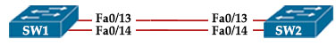
Which set of commands must be applied to the two switches to configure an LACP Layer 2 EtherChannel?
Option A  SW1(config)#interface range f0/13 -14  SW1(config-if-range)#channel-group 1 mode desirable  SW2(config)#interface range f0/13 -14  SW2(config-if-range)#channel-group 1 mode passive | Option B  SW1(config)#interface range f0/13 -14  SW1(config-if-range)#channel-group 1 mode on  SW2(config)#interface range f0/13 -14  SW2(config-if-range)#channel-group 1 mode passive
Option C  SW1(config)#interface range f0/13 -14  SW1(config-if-range)#channel-group 1 mode active  SW2(config)#interface range f0/13 -14  SW2(config-if-range)#channel-group 1 mode passive | Option D  SW1(config)#interface range f0/13 -14  SW1(config-if-range)#channel-group 1 mode auto  SW2(config)#interface range f0/13 -14  SW2(config-if-range)#channel-group 1 mode passive
A. Option A
B. Option B
C. Option C
D. Option D

Answer: C
Question 13.83
An administrator is configuring a Cisco Catalyst switch so that it will accept management connections only from hosts in the 203.0.113.0/24 network. Other traffic passing through the switch must transit without interruption. Which two configurations must the engineer apply to the router? (Choose two)
A. ip access-list extended Management
permit tcp any range 22 23 203.0.113.0 0.0.0.255
B. line vty 0 15
access-class Management in
C. ip access-list standard Management
permit 203.0.113.0 255.255.255.0
D. interface range vlan 1 – 4094
ip access-group Management out
E. ip access-list standard Management
permit 203.0.113.0 0.0.0.255

Answer: B E
Explanation
When applying access-list to line vty we must use “access-class”, not “access-group”.
The access-list command “permit tcp any range 22 23 203.0.113.0 0.0.0.255” means permit TCP traffic from any source with range 22 (SSH) and 23 (Telnet) to the destination 203.0.113.0/24 (not from source 203.0.113.0/24) so answer A is not correct.
Answer C is not correct as it used wrong wildcard mask 255.255.255.0. It should be 0.0.0.255.
Answer D is not correct as other traffic will be dropped but the questions asks “Other traffic passing through the switch must transit without interruption”.
Question 13.84
Which interface on the WLC is limited to one when LAG is in use?
A. AP-manager
B. virtual
C. trunk
D. service

Answer: A
Explanation
If link aggregation (LAG) is enabled, there can be only one AP-manager interface.
Reference: https://www.cisco.com/c/en/us/td/docs/wireless/controller/7-5/configuration-guide/b_cg75/b_cg75_chapter_011100.html
Question 13.85
Refer to the exhibit.
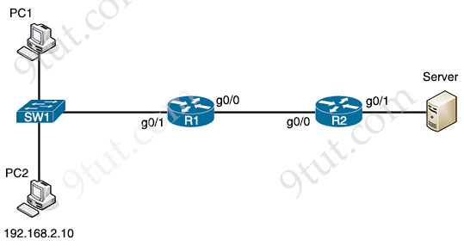
Connections must be blocked from PC2 to the file server while still allowing PC2 to connect to other network hosts and devices. Which configuration must be used to complete the task?
Option A  R1(config)#access-list 1 permit 192.168.2.10  R1(config)#access-list 1 deny any  R1(config)#interface g0/1  R1(config-if)#ip access-group 1 out | Option B  R2(config)#access-list 1 deny 192.168.2.10  R2(config)#access-list 1 permit any  R2(config)#interface g0/1  R2(config-if)#ip access-group 1 out
Option C  R2(config)#access-list 1 permit 192.168.2.10  R2(config)#access-list 1 deny 192.168.2.0 0.0.0.255  R2(config)#interface g0/1  R2(config)#ip access-group 1 in | Option D  R1(config)#access-list 1 deny 192.168.2.10  R1(config)#access-list 1 permit 192.168.2.0 0.0.0.255  R1(config)#interface g0/0  R1(config-if)#ip access-group 1 in
A. Option A
B. Option B
C. Option C
D. Option D

Answer: B
Explanation
Block connection from R2 to Server -> “deny 192.168.2.10” and we should apply to R2 which is closest to the Server so that it does not affect other devices.
Question 13.86
Which protocol does a REST API use to communicate?
A. HTTP
B. STP
C. SNMP
D. SSH

Answer: A
Question 13.87
What is a function of a firewall on an enterprise network?
A. It acts as the intermediary device between the enterprise and its ISP
B. It serves as a default gateway to hosts on the internet
C. It processes traffic based on stateless inspection
D. It allows and denies ingress and egress traffic

Answer: D
Question 13.88
Which encryption mode is used when a packet is sent from a site-to-site VPN connection where the source and destination IP address portion of a packet is unencrypted?
A. PPTP
B. Secure Shell
C. Transport
D. PPPoE

Answer: C
Explanation
Site-to-site VPN uses IPsec for encryption. IPsec has two modes: Tunnel and Transport mode.
Transport Mode: The main difference in transport mode is that it retains the original IP header. In other words, payload data transmitted within the original IP packet is protected, but not the IP header.
Question 13.89
Refer to the exhibit.
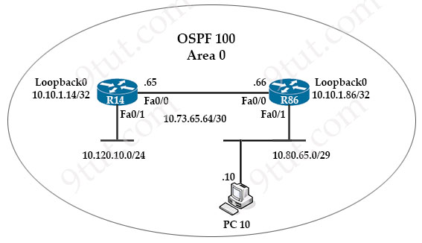
An engineer just installed network 10.120.10.0/24. Which configuration must be applied to the R14 router to add the new network to its OSPF routing table?
A. router ospf 100
network 10.120.10.0 0.0.0.255 area 0
B. router ospf 100 area 0
network 10.120.10.0 0.0.0.255
C. router ospf 120
network 10.120.10.0 255.255.255.0 area 0
ip route 10.120.10.0 255.255.255.0 fa0/1
D. router ospf 100
network 10.120.10.0 255.255.255.0 area 0

Answer: A
Question 13.90
Which key function is provided by the data plane?
A. making routing decisions
B. exchanging routing table data
C. forwarding traffic to the next hop
D. originating packets

Answer: C
Question 13.91
Refer to the exhibit.
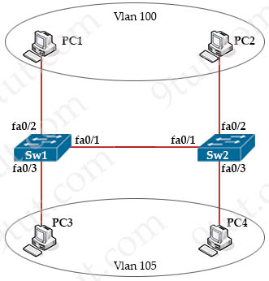
An engineer configures interface fa0/1 on SW1 and SW2 to pass traffic from two different VLANs. For security reasons, company policy requires the native VLAN to be set to a nondefault value. Which configuration meets this requirement?
Option A  Switch(config-if)#switchport mode dynamic  Switch(config-if}#switchport access vlan 100,105  Switch(config-if)#switchport trunk native vlan 1 | Option B  Switch(config-if)#switchport mode access  Switch(config-if)#switchport trunk encapsulation dot1q  Switch(config-if)#switchport access vlan 100.105  Switch(config-if)#switchport trunk native vlan 3
Option C  Switch(config-if)#switchport mode trunk  Switch(config-if)# switch port trunk encapsulation isl  Switch(config-if)#switchport trunk allowed vlan 100,105  Switch(config-if)#s witch port trunk native vlan 1 | Option D  Switch(config-if)#switchport mode trunk  Switch(config-if)#switchport trunk encapsulation dot1q  Switch(config-if)#switchport trunk allowed vlan 100,105  Switch(config if)#switchport trunk native vlan 3
A. Option A
B. Option B
C. Option C
D. Option D

Answer: D
Explanation
The default value of native VLAN is 1 so we have to use another number for non-default value. Also there are two different VLANs so we have to set both ends to mode trunk.
Question 13.92
Which fact must the engineer consider when implementing syslog on a new network?
A. Syslog defines the software or hardware component that triggered the message
B. By default, all message levels are sent to the syslog server
C. The logging level defines the severity of a particular message
D. There are 16 different logging levels (0-15)

Answer: C
Question 13.93
Which cable type must be used when connecting a router and switch together using these criteria?
– Pins 1 and 2 are receivers and pins 3 and 6 are transmitters
– Auto detection MDI-X is unavailable
A. crossover
B. rollover
C. console
D. straight-through

Answer: D
Explanation
When auto-MDIX is enabled, the interface automatically detects the required cable connection type (straight-through or crossover) and configures the connection appropriately. When connecting to switches without the auto-MDIX feature, straight-through cables must be used to connect to devices such as servers, workstations, or routers and crossover cables must be used to connect to other switches or repeaters.
Reference: https://community.cisco.com/t5/switching/auto-mdix-in-switch/td-p/1603099
(Without MDI-X) To specify when we use crossover cable or straight-through cable, we should remember:
Group 1: Router, Host, Server
Group 2: Hub, Switch
One device in Group 1 + One device in Group 2: use straight-through cable
Two devices in the same group: use crossover cable
Question 13.94
Refer to the exhibit.
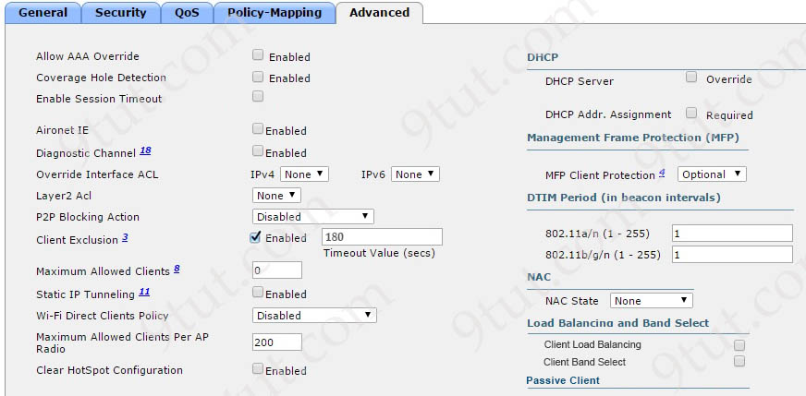
An administrator is configuring a new WLAN for a wireless network that has these requirements
– Dual-band clients that connect to the WLAN must be directed to the 5-GHz spectrum
– Wireless clients on this WLAN must be able to apply VLAN settings on the returned RADIUS attributes
Which two actions meet these requirements? (Choose two)
A. Enable the Client Band Select option.
B. Enable the Coverage Hole Detection option
C. Enable the Allow AAA Override option
D. Set the MFP Client Protection option to Required
E. Enable the Aironet IE option

Answer: A C
Explanation
Client Band Select is a new feature that encourages dual band clients to connect to 5 G-Hz networks. Band select is disabled by default. The Band Select function provides a better wireless experience for users.
The AAA Override option of a WLAN enables you to configure the WLAN for identity networking. It enables
you to apply VLAN tagging, Quality of Service (QoS), and Access Control Lists (ACLs) to individual clients
based on the returned RADIUS attributes from the AAA server.
Reference: https://www.cisco.com/c/en/us/td/docs/wireless/controller/7-4/configuration/guides/consolidated/b_cg74_CONSOLIDATED/m_configuring_aaa_override.pdf
Question 13.95
What is a similarity between global and unique local IPv6 addresses?
A. They are part of the multicast IPv6 group type
B. They are routable on the global internet
C. They are allocated by the same organization
D. They use the same process for subnetting

Answer: D
Question 13.96
What is the purpose of the service-set identifier?
A. It identifies a wireless network for a mobile device to connect
B. It identifies the wired network to which a network device is connected
C. It identifies the wireless network to which an application must connect
D. It identifies the wired network to which a user device is connected

Answer: A
Explanation
The service-set identifier (SSID) is a unique identifier that wireless networking devices use to establish and maintain wireless connectivity.
Reference: https://www.cisco.com/c/en/us/td/docs/wireless/access_point/1300/12-2_15_JA/configuration/guide/o13ssid.html
Question 13.97
In what way does a network supervisor reduce maintenance costs while maintaining network integrity on a traditionally managed network?
A. They install an automated network-monitoring system to provide early warning of network issues
B. They employ additional network administrators to proactively manage the network
C. They use automation to centralize network-management tasks
D. They automate change-management processes that verify issue resolution

Answer: C
Question 13.98
How does a network administrator securely manage an AP in lightweight mode?
A. using the WLC GUI via HTTPS
B. using the CLI via an out-of-band connection
C. using the CLI via a virtual interface with SSH
D. using the AP GUI via an in-band SSH connection

Answer: A
Question 13.99
Which protocol is implemented when an organization must verify network performance, troubleshoot issues and use an agent to communicate between monitoring tools and end devices?
A. FTP
B. NTP
C. NFS
D. SNMP

Answer: D
Question 13.100
What is the difference between AAA authentication and authorization?
A. Authentication controls the system processes a user accesses, and authorization logs the activities the user initiates.
B. Authentication identifies a user who is attempting to access a system, and authorization validates the user s password
C. Authentication identifies and verifies a user who is attempting to access a system, and authorization controls the tasks the user performs
D. Authentication verifies a username and password, and authorization handles the communication between the authentication agent and the user database

Answer: C
Question 13.101
Which syslog message logging level displays interface line protocol up/down events?
A. informational
B. alerts
C. debugging
D. notifications

Answer: D
Explanation
An example of interface line protocol down is shown below:
%LINEPROTO-5-UPDOWN: Line protocol on Interface FastEthernet0/1, changed state to down
Number 5 in the above message represents for the Notification Level (Normal, but significant, conditions exist).
The Syslog levels are:
Level | Keyword | Description
0 | emergencies | System is unusable
1 | alerts | Immediate action is needed
2 | critical | Critical conditions exist
3 | errors | Error conditions exist
4 | warnings | Warning conditions exist
5 | notification | Normal, but significant, conditions exist
6 | informational | Informational messages
7 | debugging | Debugging messages
In fact there are two correct answers in this question: Notification and informational but the first answer is enough.
Question 13.102
Which standard is required when more than one distribution system port and only one IP address are configured for a Cisco WLC?
A. 802.3ad
B. 802.1q
C. 802.1d
D. 802.1af

Answer: A

